Phase 2 Design Document
Secure Appointment and Follow-Up Management System for an Independent Financial Consultant
Course: CPS412
Project Phase: Phase 2 – Problem Description and Solution Design
Client: Sadeed Ahmad
Organization: World Financial Group (WFG)
Type of Solution: Company-based
Prepared by: Xin Wu Wang, Wadeed Ahmad, Hargun Singh, Sojas Singh Batra, Rohan Shamis

Table of Contents

1. Introduction
The client is an independent financial consultant affiliated with World Financial Group (WFG) who manages multiple client appointments and follow-up communications on a daily basis. Currently, these tasks are handled manually using phone calls, emails, and personal calendar reminders. While this approach may be sufficient for a small number of clients,it becomes increasingly difficult to manage as the client base grows, leading to inefficiencies and a higher risk of errors or missed commitments.
Missed appointments occur due to the absence of automated reminders, resulting in wasted time and reduced productivity. Additionally, follow-up communication after consultations is inconsistent, as there is no centralized system to track meeting outcomes, required documents, or next steps. This lack of organization can negatively impact client satisfaction and professional reliability, while also harming the consultant’s reputation and future business opportunities.
Furthermore, financial consultations involve sensitive personal and financial data, making secure and organized communication essential. The absence of a structured digital system increases the risk of human error, miscommunication, and poor data management practices.
This project aims to design a secure, efficient, and user-friendly digital solution that streamlines client management processes. It will automate appointment reminders, track follow-up activities, and systematically organize client interaction records to improve accuracy and reduce administrative workload. In addition, it will incorporate robust data privacy and security measures to ensure that sensitive client information is protected and handled in compliance with relevant standards. By enhancing organization, reliability, and communication, the solution seeks to improve overall operational efficiency and strengthen client relationships.

2. Requirements Analysis
The requirements of the proposed system are derived from the client’s need to improve efficiency ,reduce missed appointments,and maintain consistent communication with clients.The system must address both operational challenges and data management concerts while remaining easy to use.

2.1 Functional Requirements
The system must provide core functionalities that directly support the consultant’s daily operations:
- Appointment Scheduling System:
The system must allow the consultant to create,edit,and manage appointments through an intuitive interface. It should include date,time,client details,and service type.The system must also prevent scheduling conflicts by checking availability automatically.

- Automated Reminder System:
The system must automatically send reminders to clients before scheduled appointments.These reminders should be customizable(e.g., 24 hours and 1 hour before the meeting) and delivered through multiple communication channels such as email or SMS.

- Client Management System:
The system must store and organize client information,including names,contact details,appointments history,and notes.This enables the consultant to maintain long term relationships and quickly access relevant client information.

- Follow-up Tracking System:
After each consultation, the system must allow the consultant to create follow-up tasks, set deadlines, and track completion status. Notifications should be triggered for pending follow-ups to ensure consistent communication.

- Dashboard and Reporting:
A centralized dashboard must display key information such as upcoming appointments, overdue follow-ups, and recent client interactions. This helps the consultant stay organized and prioritize tasks efficiently.

2.2 Non-Functional Requirements
In addition to functionality, the system must meet quality and performance expectations:

- Security and Privacy:
The system must protect sensitive client data through encryption, secure authentication, and controlled access. It must comply with relevant data protection regulations such as PIPEDA to ensure lawful handling of personal information.

- Usability:
Since the client may not have advanced technical knowledge, the system must be simple, intuitive, and easy to navigate. Minimal training should be required to operate the system effectively.

- Performance:
The system must respond quickly to user actions, with minimal loading times. Real-time updates for scheduling and notifications are essential for smooth operation.

- Reliability:
The system must operate consistently without crashes or data loss.Backup mechanisms should be implemented to ensure data recovery in case of system failure.

- Scalability:
The system must be capable of handling an increasing number of clients, appointments, and stored data as the business grows over time.

- Accessibility:
The system should be accessible on multiple devices,including desktops,tablets,and smartphones,allowing the consultant to manage operations from anywhere.
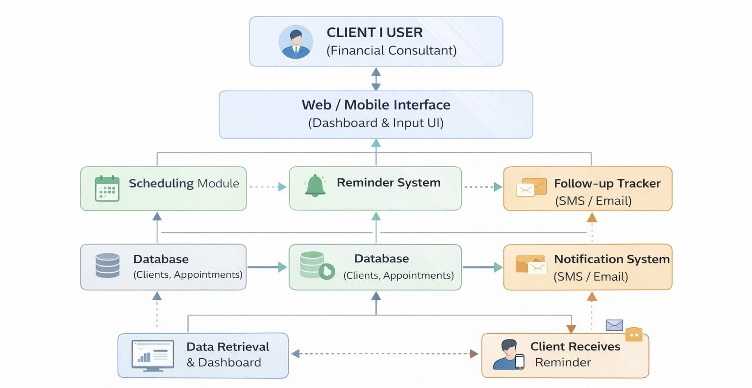

3. Proposed Solution

3.1 Overview of the Proposed Solution
The proposed solution is a secure, web-based Client Relationship Management (CRM) system designed for an independent financial consultant affiliated with World Financial Group (WFG). The system addresses the key inefficiencies identified in the problem statement, including missed appointments due to the lack of automated reminders, inconsistent follow-up communication after consultations, and the absence of a centralized system for managing sensitive client information.
The platform provides a single, browser-accessible interface that automates essential tasks such as appointment scheduling, reminder delivery, and follow-up tracking. By consolidating all client interactions into one organized system, it eliminates the need for manual processes such as phone calls, scattered emails, and personal calendar reminders. The system is also designed to support future growth as the consultant's client base expands over time.
The solution requires no software installation and is accessible from any device, including desktops, laptops, tablets, and smartphones, allowing the consultant to manage client relationships efficiently from any location.

3.2 Core Modules and Functionality
The system comprises four main modules, each designed to address a specific challenge identified during client engagement. Figure 1 provides a visual overview of all four modules and their key features.
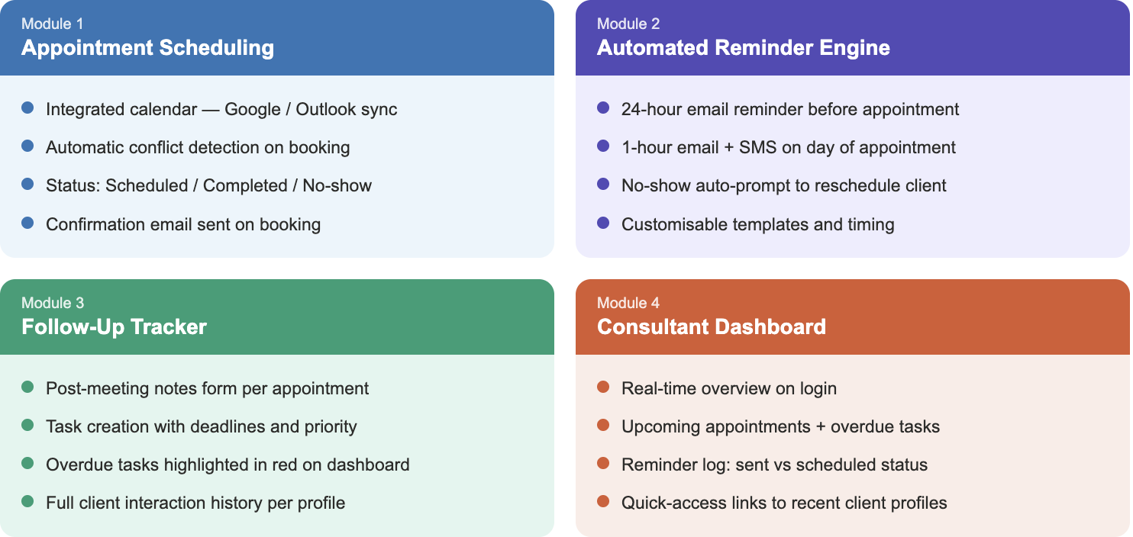

Figure 3.1: Overview of the four core modules of the WFG CRM system.

3.2.1 Appointment Scheduling Module
This module allows the consultant to create, view, edit, and cancel client appointments through an integrated calendar interface. It supports two-way synchronization with external calendar tools such as Google Calendar and Microsoft Outlook, ensuring all bookings are reflected in real time across platforms. Automatic conflict detection prevents double-booking by verifying the consultant's availability before confirming any new appointment.
Key features include:
- Creation of appointments with client name, date, time, meeting type (new client, follow-up, policy review), and notes
- Two-way synchronization with Google Calendar or Microsoft Outlook
- Automatic conflict detection to prevent double-booking
- Appointment status tracking: Scheduled, Completed, No-show, Rescheduled
- Automated confirmation email sent to the client upon booking

3.2.2 Automated Reminder Engine
This module reduces missed appointments by automatically sending reminders to clients once a meeting is confirmed in the system. No additional input is required from the consultant—the reminder sequence triggers automatically, directly addressing the missed-appointment problem identified in the problem statement. Reminders are delivered through SendGrid (email) and Twilio (SMS). The consultant can customize reminder timing and message templates from the settings panel.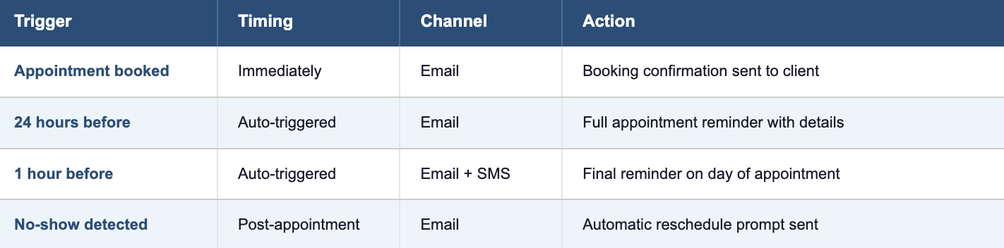
Figure 3.2: Automated reminder sequence triggered per appointment.
The reminder sequence is as follows:
- A 24-hour email reminder is sent to the client the day before the appointment
- A 1-hour email and SMS reminder sent on the day of the appointment
- An automated follow-up message is sent if the client does not attend, prompting rescheduling
- Clients can confirm, cancel, or request rescheduling directly through the reminder message

3.2.3 Follow-Up Tracking Module
This module ensures consistent post-consultation communication by allowing the consultant to record meeting outcomes and assign follow-up tasks after each appointment. After a completed consultation, the consultant completes a structured post-meeting form that captures key discussion points, documents required from the client, agreed next steps, and a deadline for each action item. The system converts these into trackable tasks and automatically flags overdue items on the dashboard.
Key features include:
- Structured post-meeting notes form linked directly to each appointment record
- Task creation with description, assigned deadline, and priority level
- Automatic escalation of overdue tasks, highlighted in red on the dashboard
- Document checklist tracking which files have been received and which are still pending
- Complete client interaction history is accessible at any time from the client profile

3.2.4 Consultant Dashboard
The dashboard provides a centralized, real-time view of all system activities, allowing the consultant to monitor appointments, follow-up tasks, and client interactions in one place. It is designed to be the first screen the consultant sees upon login, enabling fast, informed decision-making without navigating multiple sections of the system. Figure 3 below shows a mockup of the dashboard interface.
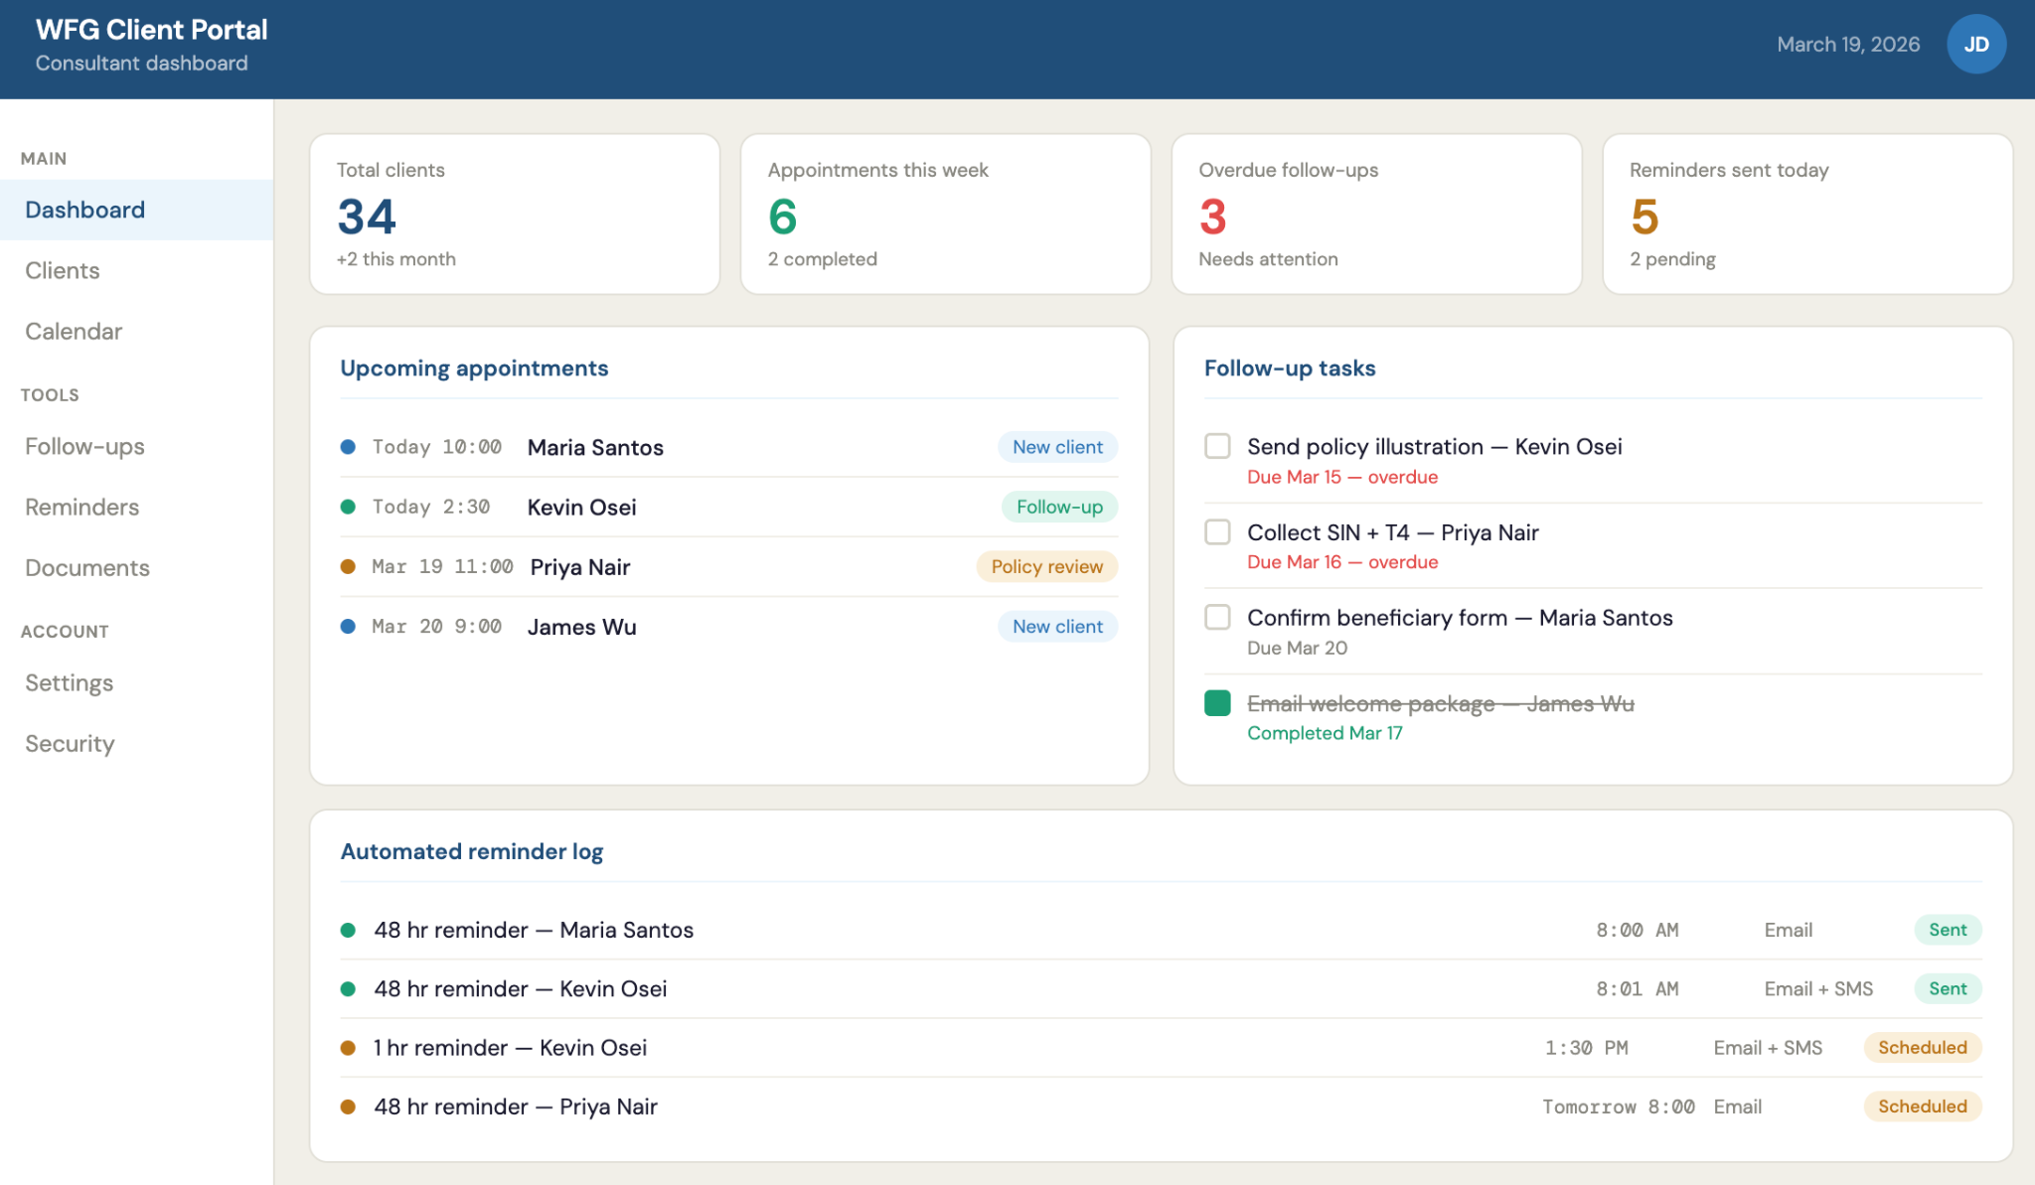
Figure 3.3: Mockup of the consultant dashboard showing metric cards, upcoming appointments, follow-up tasks with overdue indicators, and the automated reminder log.
The dashboard displays:
- Summary metrics: total active clients, appointments this week, overdue tasks, and reminders sent
- Upcoming appointments with client name, time, and meeting type
- Follow-up task list with overdue items flagged for immediate attention
- Automated reminder activity log showing sent and scheduled reminders
- Quick-access links to recent client profiles

3.3 Technical Specifications
The system is implemented as a three-tier web application consisting of a frontend presentation layer, a backend application layer, and a database storage layer. This structure ensures a clear separation of concerns, making the system maintainable, scalable, and secure.
- Frontend (Presentation Layer): React.js single-page application, accessible via any modern web browser without installation
- Backend (Application Layer): Node.js with the Express.js framework, handling all business logic, including conflict detection, reminder trigger rules, and task escalation
- Database (Storage Layer): PostgreSQL relational database storing all client records, appointments, meeting notes, and follow-up tasks.

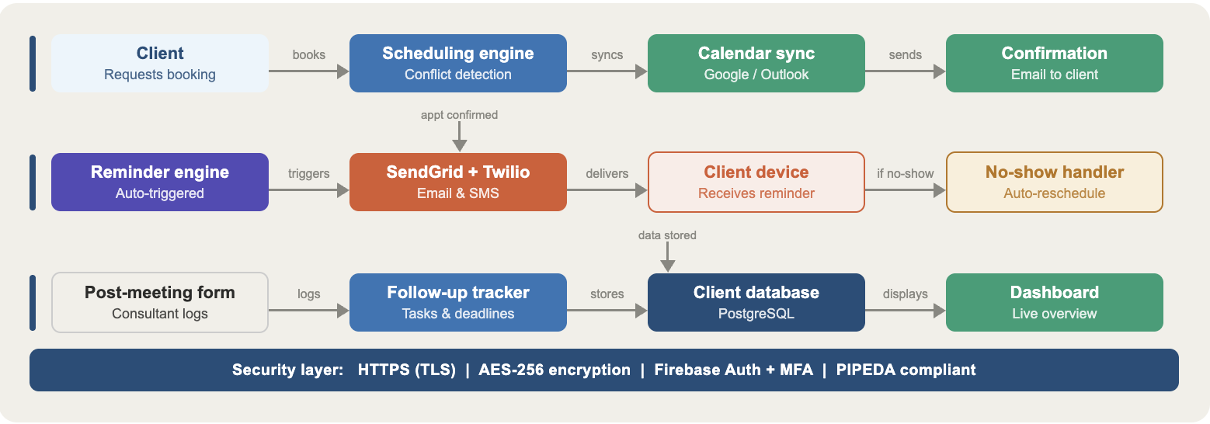
Figure 3.4: System data flow diagram showing the three operational pathways — scheduling, reminders, and follow-up tracking — all protected by a unified security layer.

3.3.1 Technology Stack
Component | Technology | Purpose
Frontend | React.js | Browser-based UI, responsive across all devices
Backend | Node.js + Express | Server logic, API handling, business rules
Database | PostgreSQL | Stores clients, appointments, tasks, and notes
Authentication | Firebase Auth | Secure login, MFA support, session management
Email notifications | SendGrid API | Automated appointment and follow-up emails
SMS notifications | Twilio API | Day-of-appointment SMS reminders to clients
Calendar sync | Google Calendar API | Two-way appointment synchronization
Frontend hosting | Vercel | Cloud deployment, CDN, HTTPS enforcement
Backend hosting | Railway | Server and database cloud hosting
Figure 3.5: Full technology stack for the WFG CRM.

3.3.2 Security Specifications
Because the system handles sensitive personal and financial data, the following security measures are applied across all modules. The system is designed to comply with PIPEDA (Personal Information Protection and Electronic Documents Act), Canada's federal privacy legislation governing the handling of personal information in commercial activities.

Security Measure | Description
HTTPS / TLS | All data in transit is encrypted — no plain-text communication is permitted
AES-256 encryption | All client records stored in the database are encrypted at rest
Firebase Auth + MFA | Hashed password storage, multi-factor authentication, and automatic session expiry
Role-based access control | Only authorized users can view or modify sensitive client records
Audit logging | All logins, data access events, and record changes are time-stamped and logged
PIPEDA compliance | Data collected only with client consent; clients may request deletion at any time

Figure 3.6: Security controls and compliance measures applied across all modules

3.4 Software and Hardware Requirements

3.4.1 Development Requirements
The following tools and technologies are required to build and deploy the system:

Category | Requirement
Runtime environment | Node.js v18 or higher
Frontend framework | React.js v18 or higher
Database | PostgreSQL v15 or higher
Version control | Git with GitHub for team collaboration
Code editor | Visual Studio Code or equivalent IDE
Third-party APIs | Firebase Auth, SendGrid, Twilio, Google Calendar API
Hosting platforms | Vercel (frontend), Railway (backend and database)

Figure 3.7: Development requirements for building and deploying the system.

3.4.2 End-User Requirements
Because the system is entirely web-based, no software installation is required on any device. The consultant only needs the following: End-User Requirements
Requirement | Specification
Device | Any desktop, laptop, tablet, or smartphone
Operating system | Windows, macOS, iOS, or Android
Browser | Google Chrome 90+, Firefox 88+, Safari 14+, or Microsoft Edge 90+
Internet connection | Minimum 1 Mbps stable broadband connection
Screen resolution | Minimum 1024 × 768 px — responsive design adapts to all screen sizes
Additional software | None required — the system runs entirely through the web browser

Figure 3.8: End-user requirements for accessing the system.

3.5 Summary
The proposed WFG Client Relationship Management System is a practical, technically sound, and security-conscious solution that directly addresses the operational challenges faced by the financial consultant. By automating appointment reminders, centralizing follow-up tracking, and providing a unified dashboard view of all client activity, the system resolves the three core inefficiencies described in the problem statement.
The use of established technologies — React.js, Node.js, PostgreSQL, and Firebase Auth — ensures the system is reliable and scalable as the consultant's client base grows. The web-based delivery model eliminates installation barriers, while the security infrastructure protects sensitive financial data in full compliance with Canadian privacy standards under PIPEDA.
Overall, the solution transforms a manual, error-prone workflow into a reliable digital system that enhances professional reliability, improves client communication, and supports sustainable growth in the consultant's financial advisory practice.

4. System Architecture
The proposed solution uses a secure three-tier web architecture to support appointment scheduling, automated reminders, follow-up tracking, and client record management for an independent financial consultant. The consultant interacts through a browser-based interface, but the backend remains the single decision point for validation, conflict detection, reminder scheduling, client response handling, task generation, and audit logging. That separation directly addresses the client’s real problem: manual coordination does not scale, is easy to forget, and is risky for sensitive financial information.

4.1 Architectural intent and design drivers
The architecture was selected to meet the project’s most important requirements: reliable scheduling, secure handling of sensitive records, fast day-to-day use by one consultant, and room to scale as appointments and clients increase.

Design driver | Project need | Architectural response
Reliability | Avoid missed appointments and forgotten follow-ups | Backend scheduling rules, reminder queue, delivery status tracking, and dashboard  visibility
Security and privacy | Protect sensitive client and financial information | Authentication, role checks, encrypted transport/storage, consent-aware records, and audit logging
Usability | Fast workflow for one consultant | Single dashboard entry point with direct navigation to clients, calendar, follow-up work, and settings
Scalability and maintainability | Support growth in  appointments, integrations, and records | Separated presentation,  application, and storage layers with connector-based external services

Figure 4.1: Architectural Design Drivers, Project Need, and Architectural Response

4.2 High-level layered architecture
At the highest level, the system is divided into presentation, application, and data/integration layers, with a cross-cutting security model applied across all three. The consultant never writes directly to the database or to third-party services. Every important action flows through the backend first so the system can enforce validation, scheduling rules, role checks, and logging consistently.

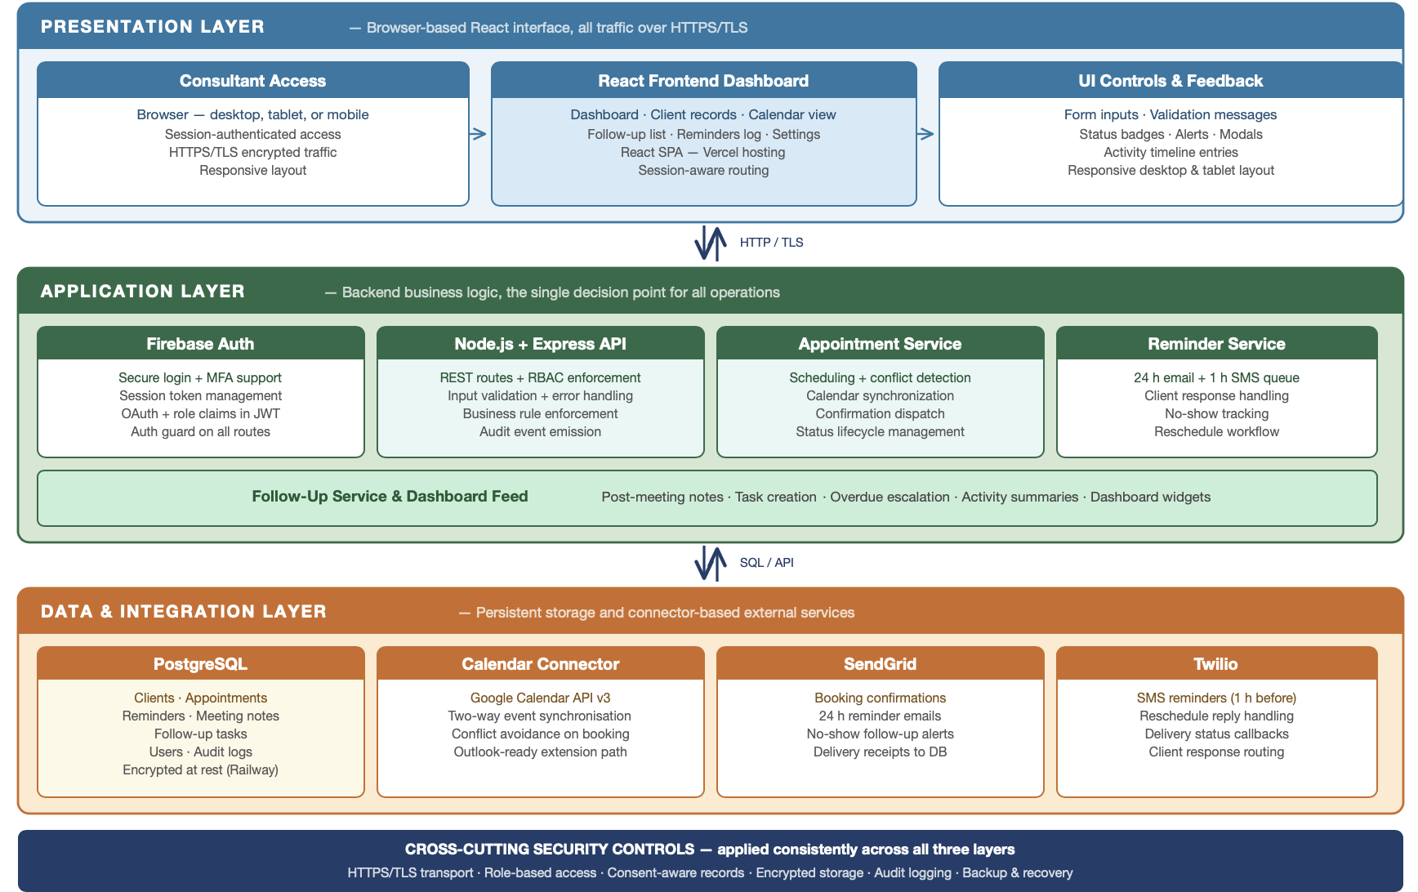

Figure 4.2: High-level layered architecture of the proposed CRM system.

Layer | Main components | Responsibility
Presentation | Login, dashboard, client screens, calendar, follow-up view | Collects user input and displays appointments, reminders, pending tasks, and client history.
Application | Express API, authentication handling, appointment service, reminder service, follow-up service | Enforces business rules, validates records, prevents conflicts, updates statuses, and generates tasks.
Data and integration | PostgreSQL, Google Calendar connector, SendGrid, Twilio | Stores records securely and connects the system to  scheduling and communication services.

Figure 4.2.1: Summary of three Architectural Layers, Main components, Responsibility

4.3 End-to-end operational workflow
The workflow is easiest to understand as one connected lifecycle: booking and confirmation, scheduled reminders and client response, then post-meeting follow-up. In each phase, the interface starts the action, but the backend decides what should be stored, what reminder should be sent, and what work should appear on the dashboard later.

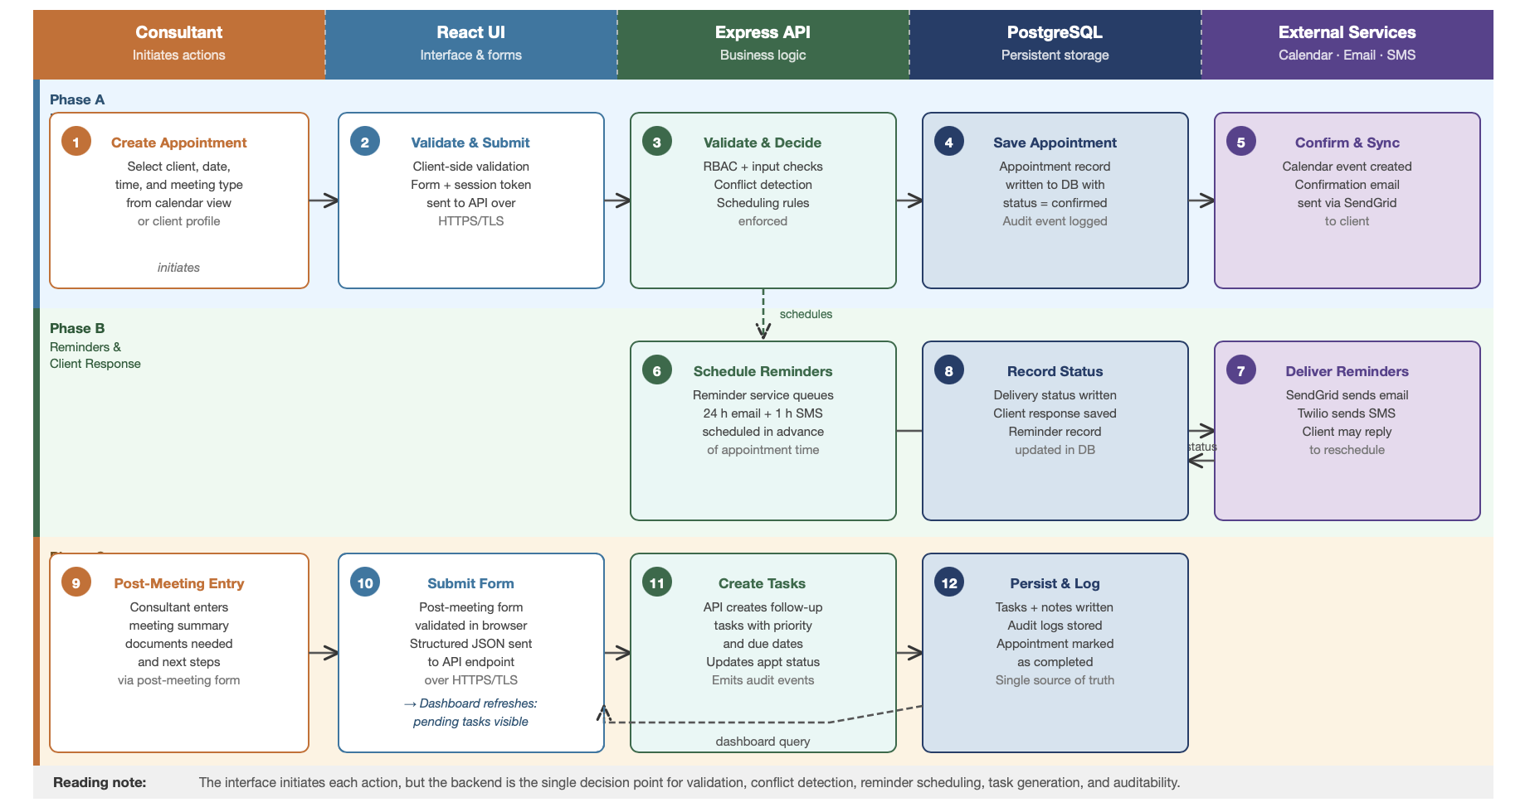Figure 4.3: Swimlane data flow from appointment creation to follow-up tracking.

Phase A stores the appointment, checks for time conflicts, synchronizes the calendar, and triggers a confirmation email. Phase B schedules the reminder sequence, delivers messages through SendGrid and Twilio, and records delivery results or client responses. Phase C converts meeting notes into structured follow-up tasks with deadlines, escalation rules, and audit visibility so the dashboard reflects the next required action.

4.4 Data architecture
The database layer stores the core business entities used by the design. Client and appointment records drive the main workflow, while reminder status, meeting notes, follow-up tasks, user accounts, and audit logs support coordination, security, and accountability. Keeping those records linked in one relational model eliminates the fragmented state created by manual phone reminders, scattered emails, and personal notes.

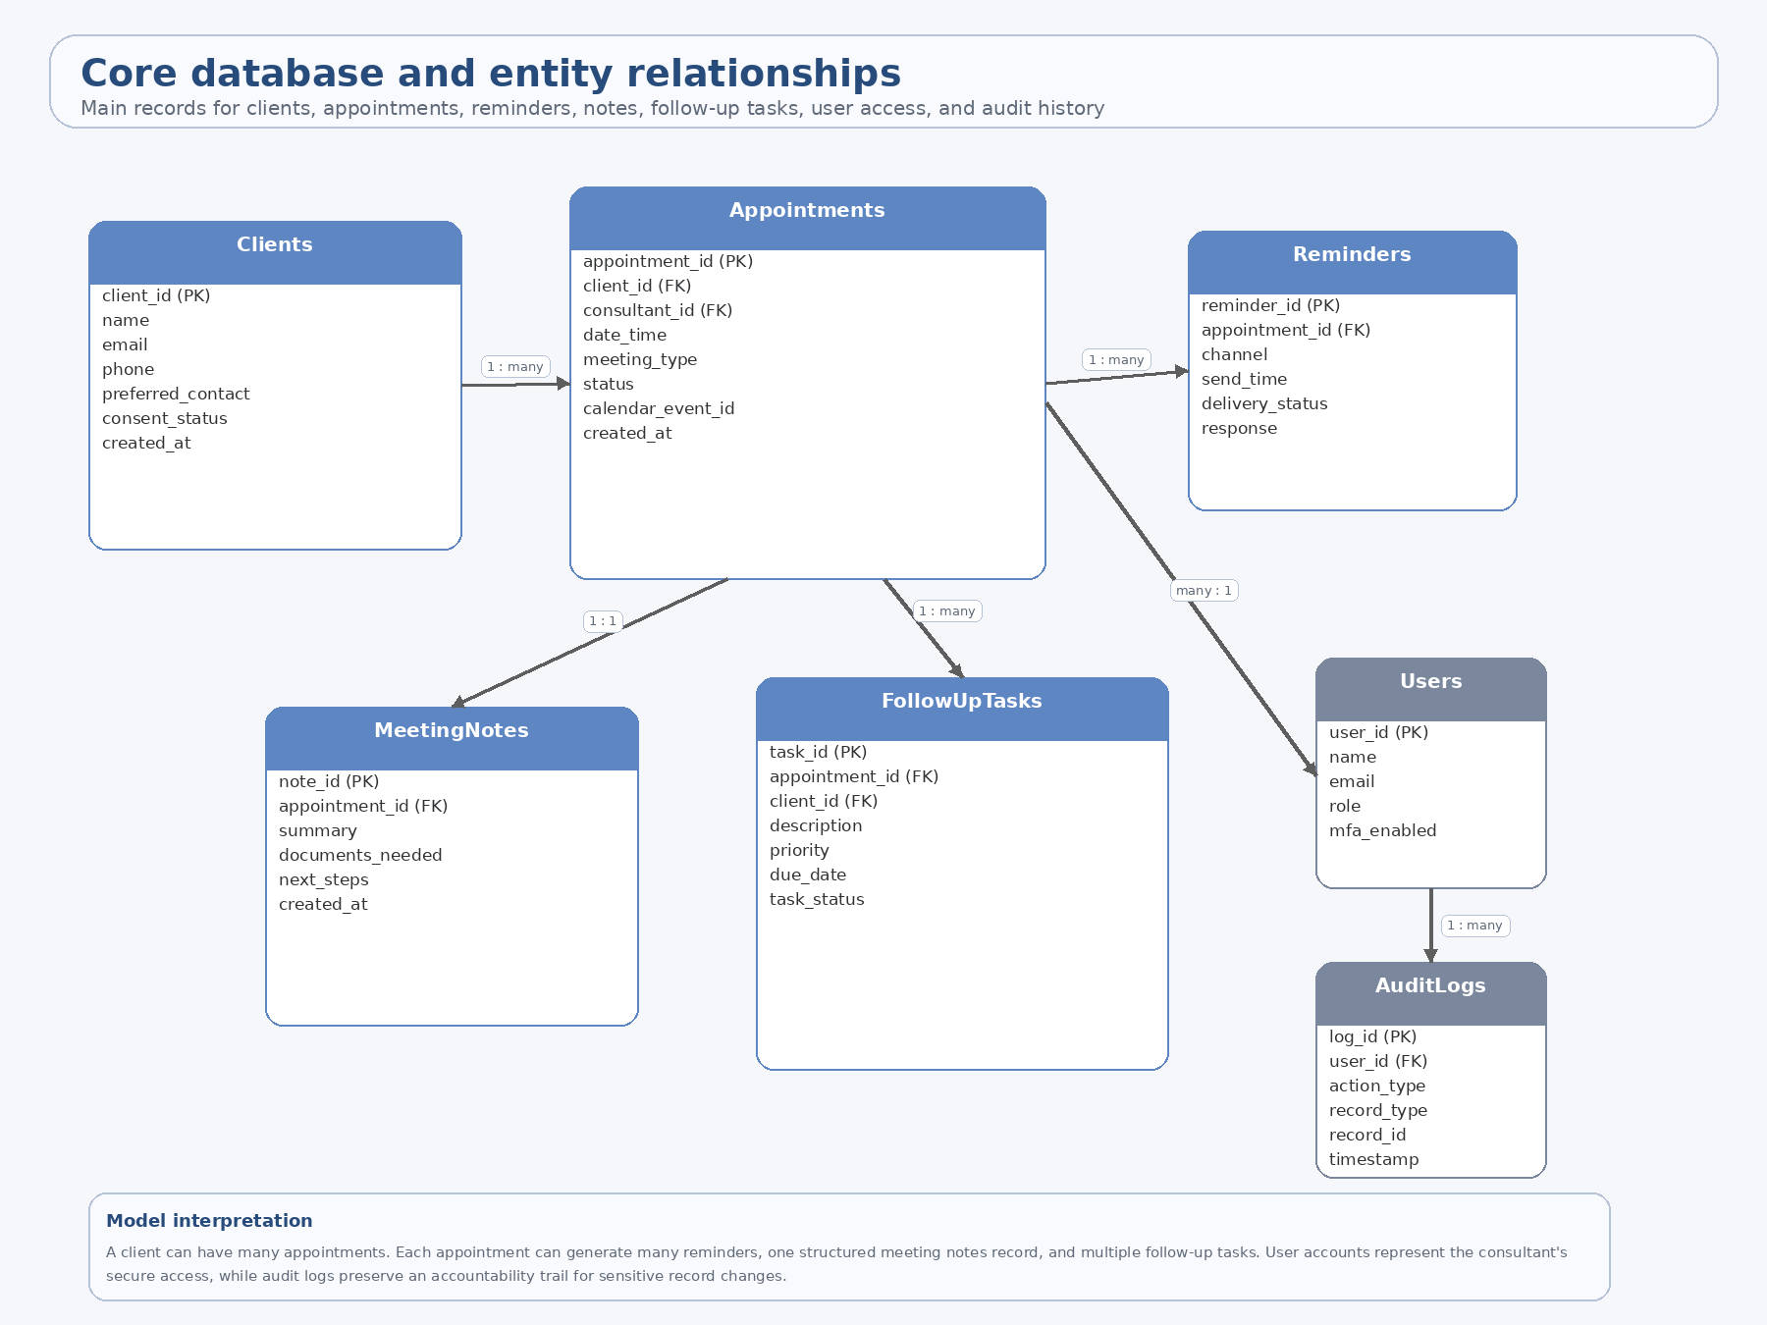Figure 4.4: Core relational model and key entity relationships.

A client can have many appointments. Each appointment can produce many reminders, one structured meeting notes record, and multiple follow-up tasks. User accounts represent the consultant’s authenticated access, while audit logs preserve a time-stamped trail of important actions. This model supports the client’s actual daily workflow because one consultation often leads to several required follow-up steps rather than one simple status change.

4.5 User interface architecture
The interface is intentionally simple because the system is designed for one consultant, not a large enterprise team. After logging in, the consultant lands on the dashboard and can move directly into client records, calendar actions, follow-up work, or settings without leaving the platform. That reduces cognitive load and makes the system practical for daily use.

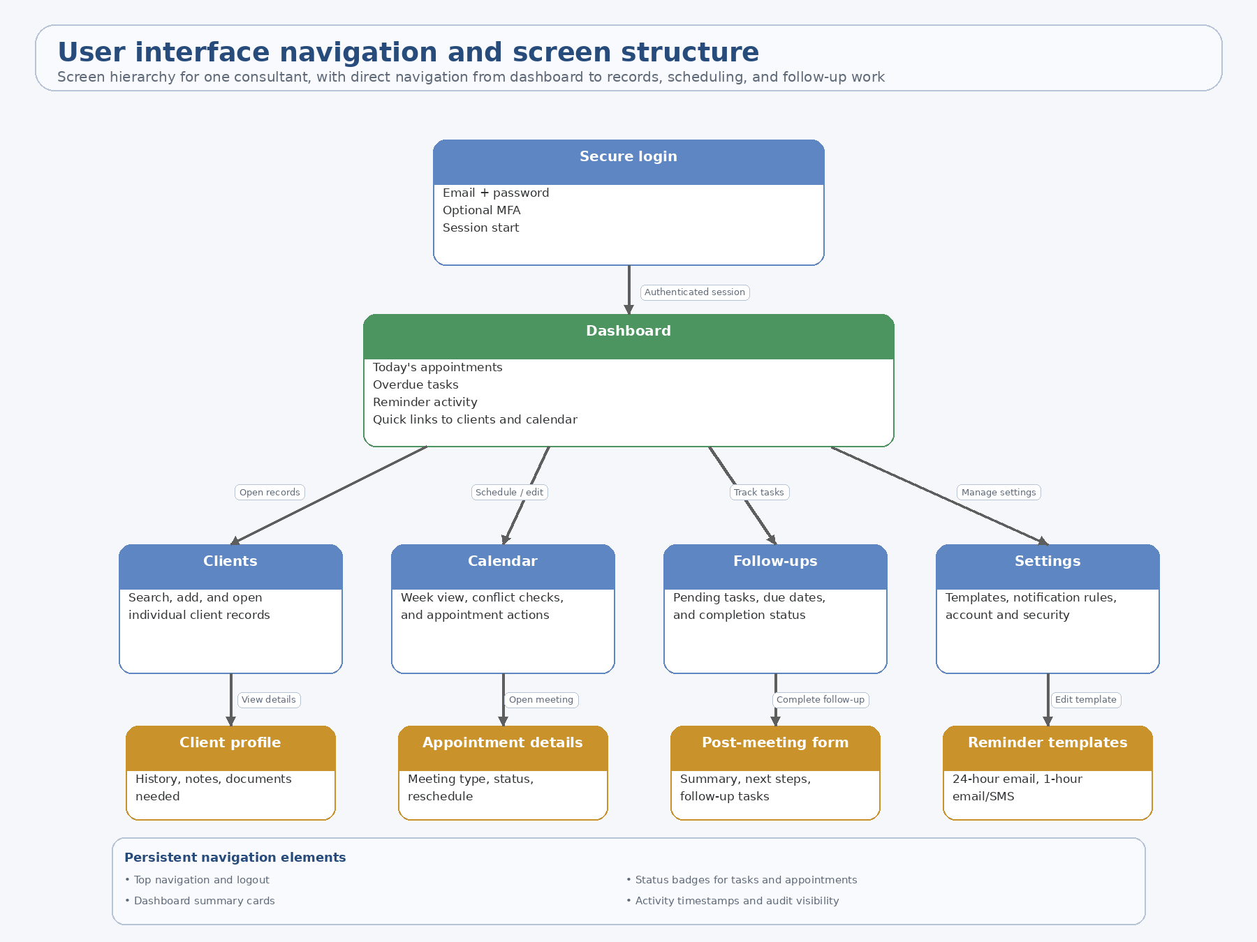Figure 4.5: Navigation map and screen hierarchy for the consultant-facing interface.

The dashboard acts as the control hub. From there, the consultant can open a client profile, inspect or reschedule an appointment, complete a structured post-meeting form, or adjust reminder templates and security settings. Persistent navigation elements such as search, status badges, timestamps, and summary cards keep the interface consistent across screens.

4.6 Security and deployment architecture
Security cannot be treated as an afterthought because the client works with sensitive personal and financial information. The deployment view shows where the main controls are enforced and how external services connect to the core system without exposing the database or business logic directly to the browser.

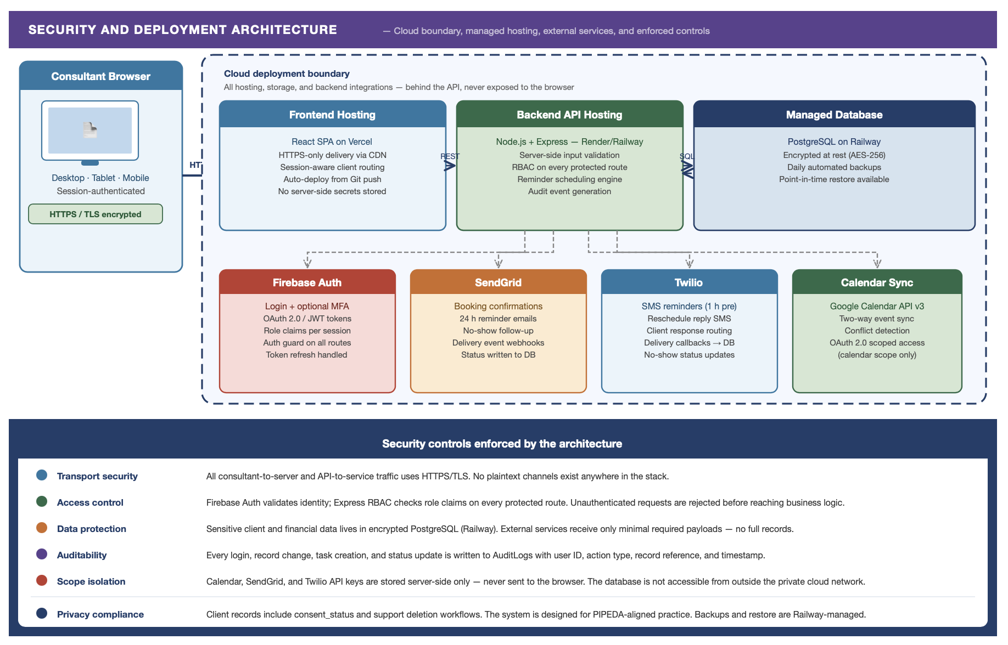Figure 4.6: Deployment boundary and security controls applied across the system.

Firebase Auth protects login and session management. HTTPS/TLS protects traffic in transit. PostgreSQL remains the protected store for appointments, notes, reminders, and follow-up data, while SendGrid, Twilio, and Google Calendar are used only through backend-controlled integrations. Important actions are written to an audit trail, and consent-aware records support privacy handling in a PIPEDA-aligned workflow.

4.7 Architectural rationale and conclusion
Overall, the architecture fits the client’s problem because it replaces disconnected tools with one secure workflow. The frontend stays simple, the backend enforces rules, and the database preserves a reliable history of appointments, reminders, notes, and follow-up actions. Together, those choices support scheduling, reminder delivery, follow-up tracking, secure login, and long term scalability.

5. Implementation Plan

5.1 Development Phases
Phase 1: Requirements Confirmation
The Development team will review the client’s needs from phase 1 and verify operational details such as reminder frequency, required client fields, appointment categories, and follow-up workflow.

Phase 2: System Design
The team will create wireframes, define the database schema, finalize system modules, and prepare the architecture and user flow diagrams. Accessibility and inclusive design requirements will be integrated during this stage rather than in a later stage.

Phase 3: Prototype Development
The team will develop the core product. The MVP for this project should include secure login, appointment creation, automated reminders, client response links, and follow-up tracking.

Phase 4: Testing
Testing will include functional testing, usability testing, accessibility testing, and security testing. Accessibility testing should check keyboard access, colour contrast, heading structure, labels, plain language, and responsive behaviour.

Phase 5: Deployment and Review
The prototype will be deployed in a cloud environment or demo server. The client will review the system and provide feedback. Based on this feedback, the team can identify future improvements such as document upload support, calendar integration, or broader notification customization.

5.2 Timeline
Week 1: Requirements confirmation and workflow finalization
Week 2: Interface design and database schema
Week 3: Building scheduling and authentication modules
Week 4: Build reminders and follow-up modules
Week 5: Testing and fixing issues
Week 6: Prepare final deployment/demo and documentation

5.3 Resource Requirements
The project will require a small student development team, laptops or development workstations, source code management, a database environment, and a web hosting platform for testing or deployment. It will also require an email API and an optional SMS service if text reminders are to be included.

The team will need:
- Front-end framework or standard web stack
- Backend framework
- Relational database
- Version control tools
- Browser testing tools
- Accessibility checking tools

